TIER 1 BENEFIT HUB CONTENT

**For minor text updates in Drupal**

***Example:*** updating a phone number, rates data, a few words or sentences

VHA, VBA, and NCA digital teams: Jennifer Heiland-Luedtke, Jeff Grandon, Misty Sweet, Sandy Tadeo, Adrianne Hooten, Scott Brunner, Eric Lee, Brett Lee

1. VHA, VBA, or NCA digital team makes the update directly in Drupal.*

* *Alternatively, can initiate request to the VA.gov web content team via email or JotForm https://form.jotform.us/63385439158163 (same as today). In this scenario, the web content team creates a GitHub ticket.

1. Save the change as “Draft.” Include a brief note in Drupal about what was changed.   
     
   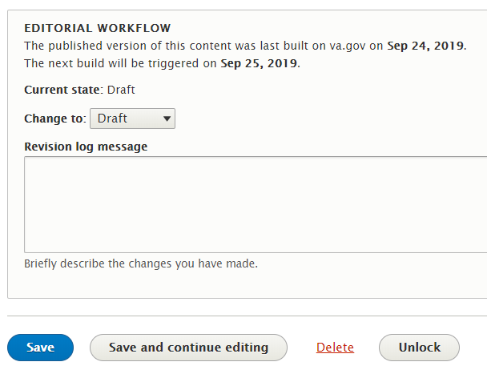
2. Email Randi Hecht Randi.hecht@va.gov and Beth Potts [beth.potts@va.gov](mailto:beth.potts@va.gov) to proofread and review for [VA.gov content style guide](https://design.va.gov/content-style-guide/) standards. (CC: [rhecht@governmentcio.com](mailto:rhecht@governmentcio.com))
   * Include the Drupal preview URL. It will look something like this: **/preview?nodeId=864**
   * If the content team makes the change in Drupal, the content person will email the SME/requestor the preview URL to review; and if applicable, CC the relevant VHA/VBA/NCA digital team POC.
3. VA.gov web content person does a quality check and changes the state to “publish” for deployment.
4. Update goes live with regular daily deployment.
   * Future state: there may be multiple deployments. As always, emergency related updates (like natural disaster alerts) are manually deployed right away.
   * VA.gov web content person emails SME and VHA, VBA, and NCA digital team POC that the update has been published.

TIER 1 BENEFIT HUB CONTENT

**For nuanced, more complex updates or new pages**

***Example:*** benefit information that requires special attention; terminology changes that affect many different pages or many different benefit categories or is global; something that needs coordination across multiple business lines or administrations

1. TYPICAL PRE-DRUPAL STEPS:

* Business contacts the VHA, VBA, and NCA digital team directly. (Or in some cases, it could be the digital team that initiates; example: parity and legacy rewriting.)
* VHA/VBA/NCA digital team syncs with the VA.gov web content team.
* Research/discovery phase, if needed: VHA/VBA/NCA digital team, SME, and web content team collaborate on content.
  + This may include VA.gov web content team conducting a content audit, IA research, SEO research, and stakeholder conversations. Web content team creates GitHub issue/epic/ticket to track work.

1. Business provides VA.gov web content team draft content (or vice versa, depending on conversation with stakeholder). SME and web content person work on editing new content in the new VA.gov style.
   * This can happen in Drupal or in Word doc, depending on how many pages and how complex.
2. VHA, VBA, or NCA digital team (or the web content person, depending on conversation) makes the update or builds the new page in Drupal. (Unless the content was drafted in Drupal in step 2.)
3. The person updating Drupal saves as “Draft” and emails SME a preview link and CC VHA/VBA/NCA digital team and/or the web content person for awareness.
   * Depending on complexity of content, the content team may also schedule a call for a walk-through.
4. SME reviews the preview page; provides feedback to the content person—either via email (if simple) or via a meeting (if complex).
   * Collaboration continues until user-friendly, SEO optimized, and accurate state is reached.
5. VA.gov content person changes state in Drupal to “In Review,” and emails Randi Hecht and Peggy Gannon to proofread.
   * Best practice: We always have a content person who did NOT work on the changes do the second or final review.
6. Randi/Peggy does a quality check (proofread); makes minor copyedits in Drupal or provides content person questions/feedback via email or GitHub ticket.
7. Content person incorporates any proofreading changes as needed.
8. Content person emails SME, and the relevant VHA/VBA/NCA digital team a final preview URL prior to changing state to “publish.”
9. Update or new page goes live with regular daily deployment.
   * VA.gov web content person emails SME and VHA, VBA, and NCA digital team POC that the update has been published.